**(6428317 Mukesh P)**

***WEEK 2***

***JUnit Testing Exercises***

***MANDATORY HANDS-ON:***

**Exercise 1: Setting Up Junit**

**SampleTest.java**

package com.example.test;

import org.junit.Test;

import static org.junit.Assert.*;

public class Sampletest {

@Test

public void sampleAdditionTest() {

int result = 2 + 3;

*assertEquals*(5, result);

}

}

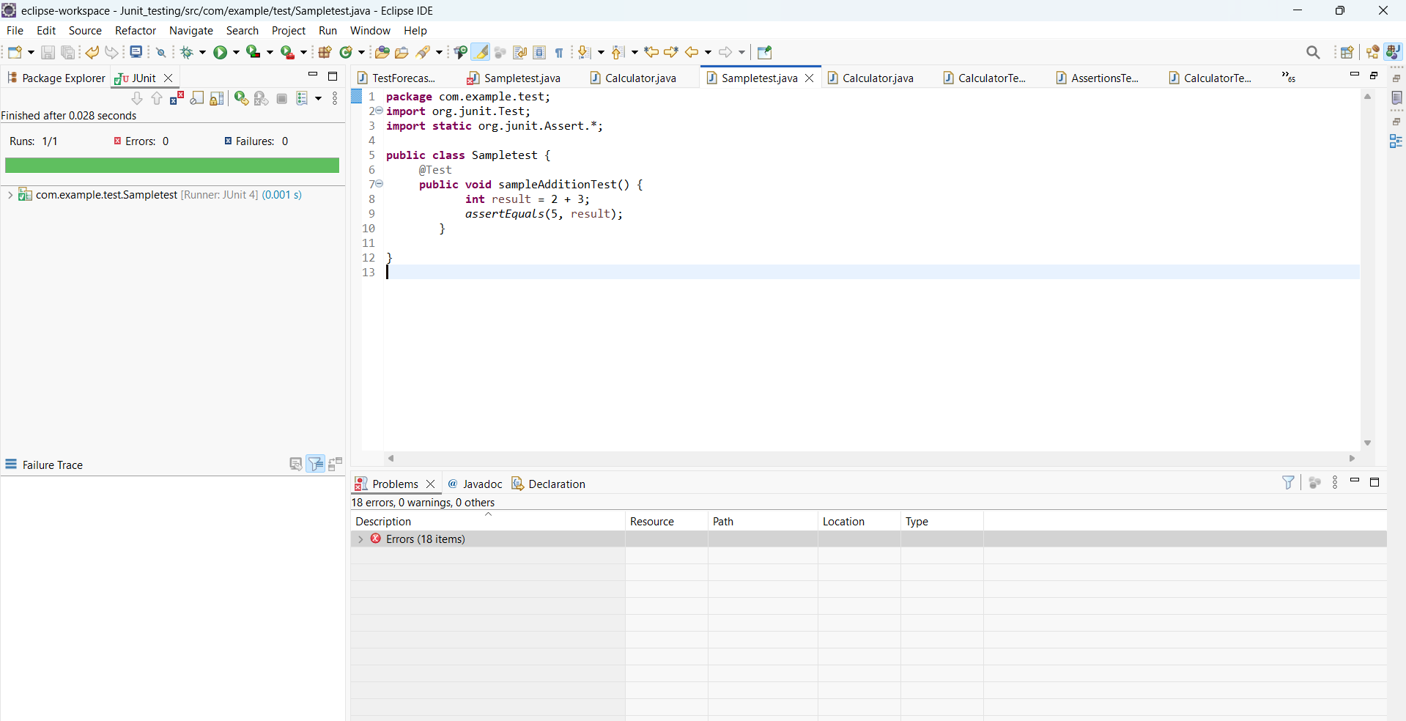

**Exercise 3: Assertions in Junit:**

package com.example.test;

import org.junit.Test;

import static org.junit.Assert.*;

public class AssertionsTest {

@Test

public void testAssertions() {

*assertEquals*(5,2+3);

*assertTrue*(5>3);

*assertFalse*(5<3);

*assertNull*(null);

*assertNotNull*(new Object());

}

}

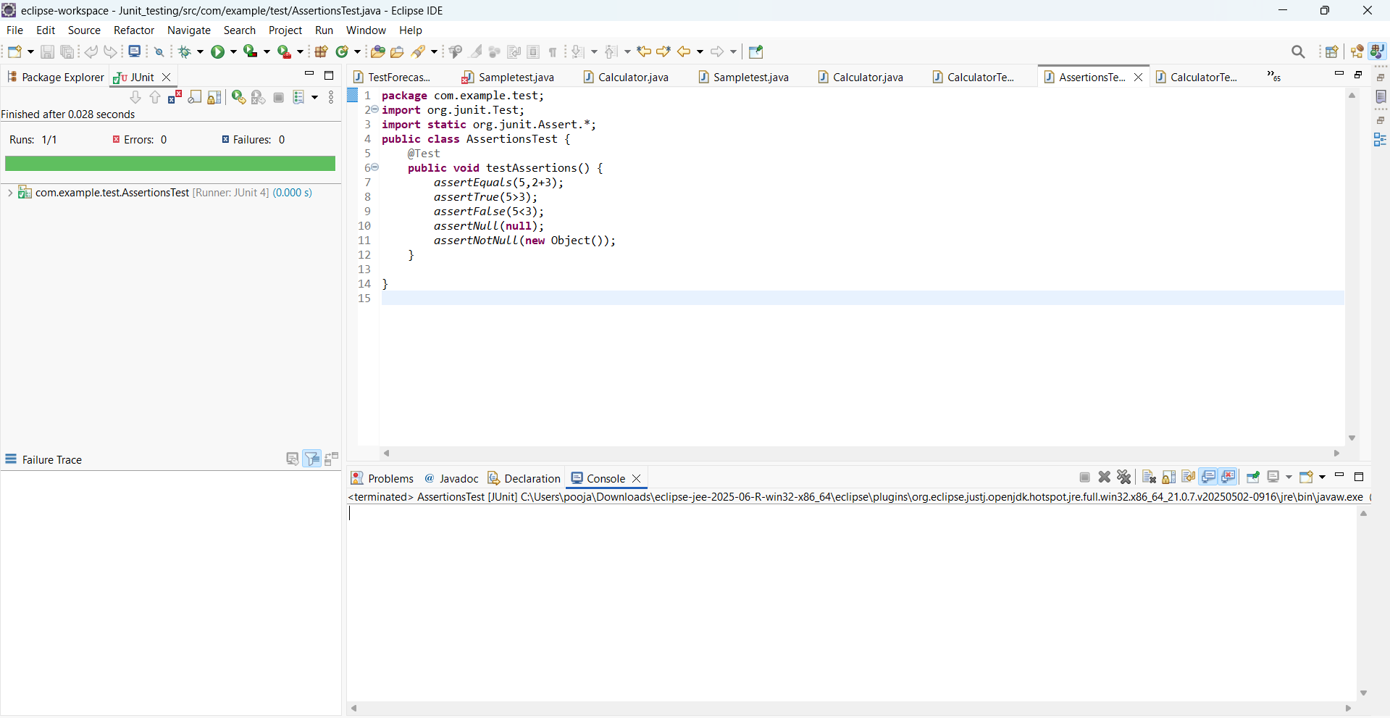

**Exercise 4: Arrange-Act-Assert (AAA) Pattern, Test Fixtures, Setup and Teardown Methods in Junit:**

package com.example.test;

import com.example.Calculator;

import org.junit.Before;

import org.junit.After;

import org.junit.Test;

import static org.junit.Assert.*;

public class CalculatorTestWithSetup {

private Calculator calc;

@Before

public void setUp() {

calc = new Calculator();

System.*out*.println("Setup complete.");

}

@After

public void tearDown() {

calc = null;

System.*out*.println("Teardown complete.");

}

@Test

public void testAddition() {

int result = calc.add(10, 5);

*assertEquals*(15, result);

}

@Test

public void testMultiplication() {

int result = calc.multiply(3, 3);

*assertEquals*(9, result);

}

}

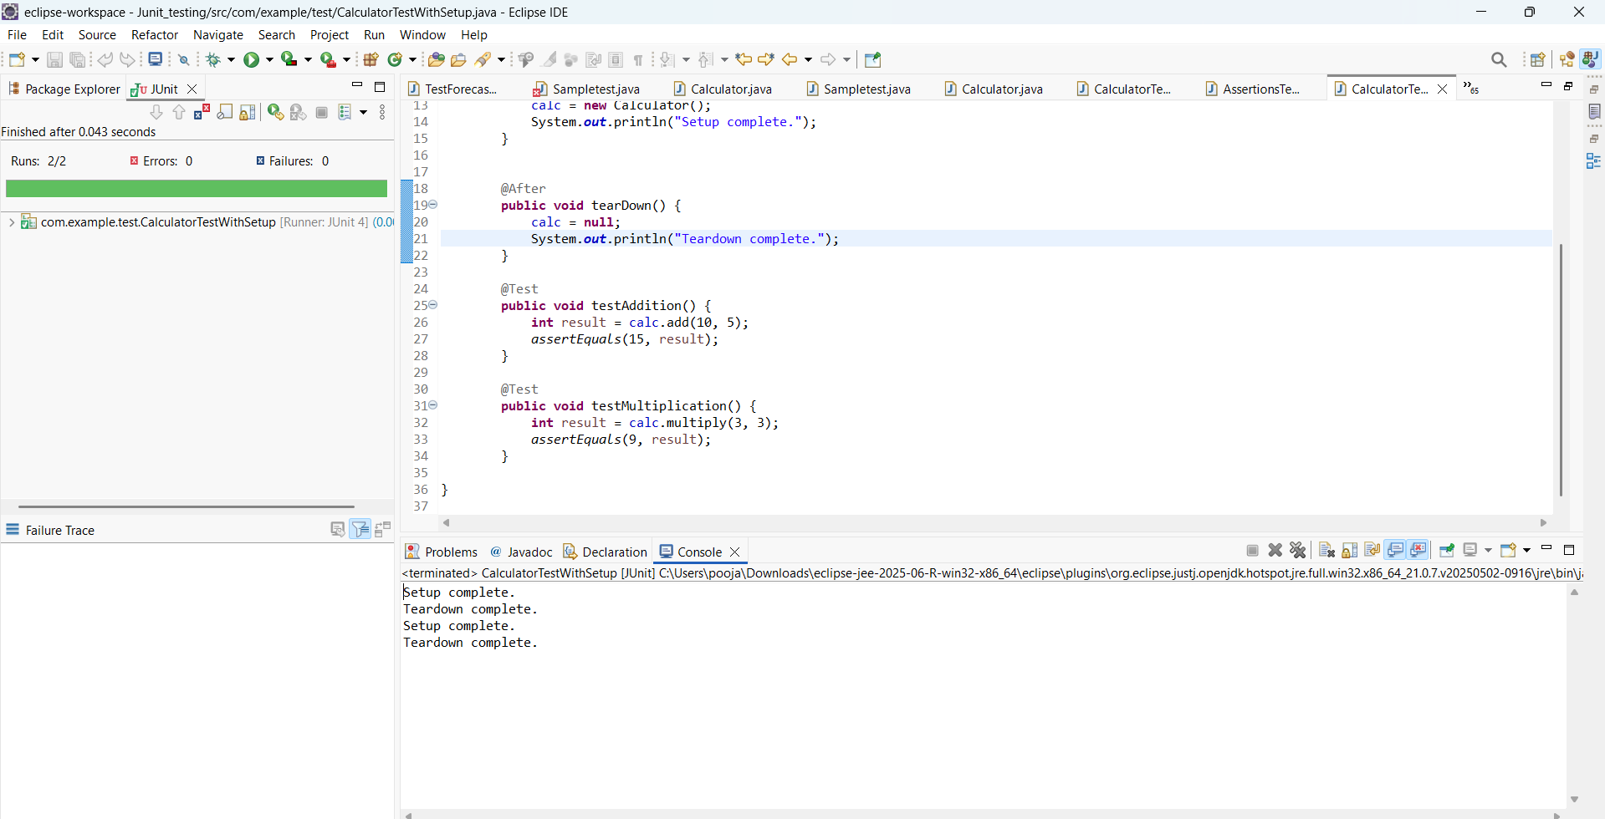

***ADDITIONAL HANDS-ON:***

**Exercise 2: Writing Basic JUnit Tests**

**Calculator.java**

package com.example;

public class Calculator {

public int add(int a, int b) {

return a + b;

}

public int multiply(int a, int b) {

return a * b;

}

}

CalculatorTest.java:

**package** com.example.test;

**import** com.example.Calculator;

**import** org.junit.Test;

**import** **static** org.junit.Assert.*;

**public** **class** CalculatorTest {

@Test

**public** **void** testAdd() {

Calculator calc = **new** Calculator();

*assertEquals*(5, calc.add(2, 3));

}

@Test

**public** **void** testMultiply() {

Calculator calc = **new** Calculator();

*assertEquals*(6, calc.multiply(2, 3));

}

}

